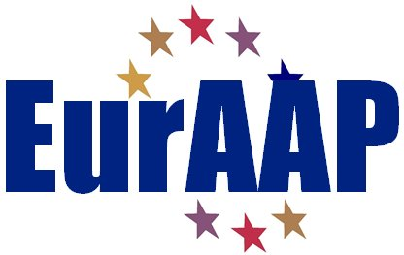

NOMINATION FORM FOR THE 2017 EurAAP AWARDS

AWARD FOR WHICH THE NOMINATION IS MADE
Please select one of the following
  - EurAAP Antenna Award
  - EurAAP Propagation Award

NOMINEE
  - Name of Nominee: Name
  - Professional Affiliation and Title: Affiliation & Title
  - Address:
Address.
  - E-mail: e-mail.
  - Education (Institution, location, degree, and year received)
Education.
  - Description of current activities:
Activities.
  - Achievement pertinent for the Award and justification of its relevance:
Achievements.
  - Proposed citation:
Citation (max. 30 words).

NOMINATOR
  - Name: Name.
  - Professional Affiliation and Title: Name.
  - Address:
Name.
  - E-mail: Name.
  - Relationship to the Nominee:
Relationship.

Endorsers (maximum 3)
  - : Names and Addresses, Emails

Note: the entire nomination form, with the exception of endorsement letters, should not exceed five pages in length (minimum 10 point font size).

Please complete the form and send it as PDF to:
Awards2017@euraap.org

Endorsement letters may accompany the nomination or be sent separately.

